

ATHARV JAIRATH

Project Zomato api

## 1.1 Plot the bar graph of number of restaurants present in Delhi NCR vs Rest of India.

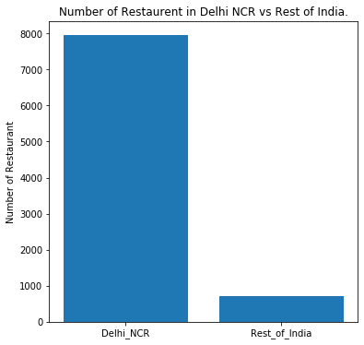

As we can Observe that the data is highly skewed toward the cities included in Delhi-NCR Vs the Rest of India.

To achieve this graph I made a new data frame with NCR cities and counted them along with the rest of India.

## 1.2 Find the cuisines which are not present in restaurant of Delhi NCR but present in rest of India .Check using Zomato API whether this cuisines are actually not served in restaurants of Delhi-NCR or just it due to incomplete dataset.

To find cuisines which are not present in restaurant of Delhi-NCR,

I made a Set of Cuisines present in NCR and Rest of India, then used Set functions to separate them.

The Cuisines that are not served in Delhi-NCR using ***Zomato.csv*** are:

1. ***Malwani***
2. ***Cajun***
3. ***BBQ***

Now to verify our data I used ***Zomato API*** , Using requests Library of python.

The Cuisines that are not served in Delhi-NCR using ***Zomato API*** are:

1. ***Cajun***
2. ***German***

Therefore, our data is incomplete as these doesn’t match.

## Find the top 10 cuisines served by maximum number of restaurants in Delhi NCR and rest of India.

### REst OF India

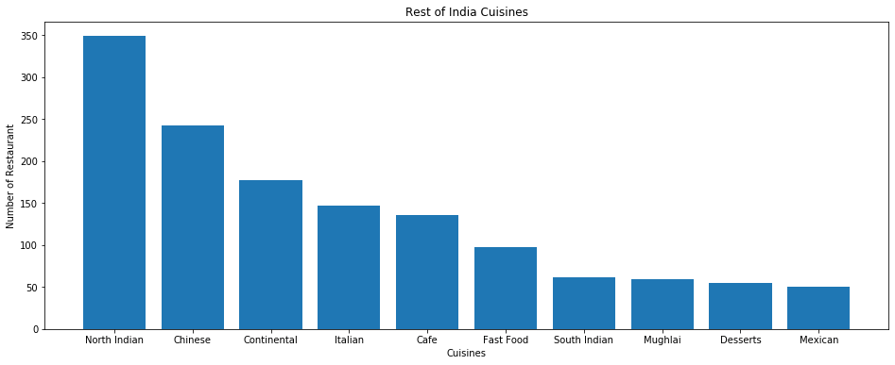

##### TOP 10 CUISINE SERVED IN MAXIMUM NUMBER OF RESTAURANTS IN REST OF INDIA:

CUISINE | NUMBER OF RESTAURANTS

North Indian | 349

Chinese | 242

Continental | 177

Italian | 147

Cafe | 136

Fast Food | 97

South Indian | 62

Mughlai | 59

Desserts | 55

Mexican | 50

### DElhi – NCR

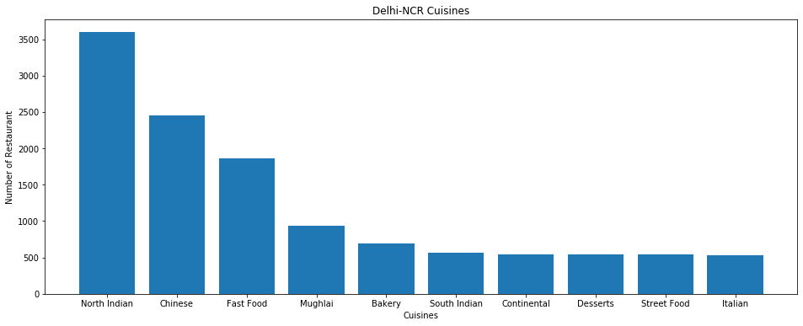

##### TOP 10 CUISINE SERVED IN MAXIMUM NUMBER OF RESTAURANTS IN DELHI-NCR:

CUISINE | NUMBER OF RESTAURANTS

North Indian | 3597

Chinese | 2448

Fast Food | 1866

Mughlai | 933

Bakery | 697

South Indian | 569

Continental | 547

Desserts | 542

Street Food | 538

Italian | 535

## Write a short detailed analysis of how cuisine served is different from Delhi NCR to Rest of India. Plot the suitable graph to explain your inference.

**Observing the Same Graphs as Above:**

## Observation :

Now we can clearly see that **North Indian** is sold in every part of India basically and loved by almost everyone In India . In NCR there is a huge trend for **Fast Food** and **Chinese**, while Continental is served the most after **North** **Indian** and **Chinese** in Rest parts of India. NCR also have a taste for **Mughlai**. We also observe that In Delhi-NCR, **Street Food** is sold a lot then in Rest of India. We can also observe that **Italian** is Consumed a lot in rest of India then Delhi-NCR, But in Delhi-NCR Restaurants also sell **Bakery** as a Cuisine. We Can also see that **Mexican** is sold in rest of India while not much in Delhi-NCR.

# Write a short detail analysis of how the rating is affected by restaurant due following features:-

## 2.1 Number of Votes given Restaurant

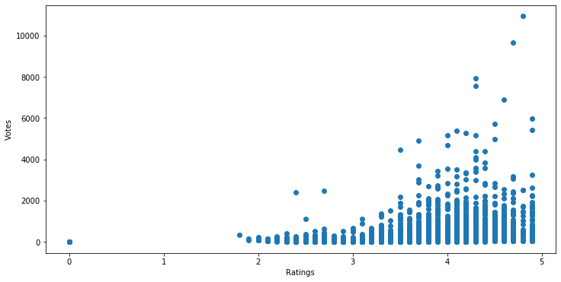

### Analysis

As we look into this graph, we can observe the following points:

1. There are very less or not at all restaurant with Rating less than **2,** and those who those who exists , got very less Votes, therefore we can say having less votes may lead to less user rating
2. In Rating **2** to **3** Shows the same trend i.e. having less votes = low user rating, but some of these restaurants have votes above 2k and still have low rating.
3. In Rating **3** to **4** it again shows the same trend, now as the rating increases the number of restaurants having high votes also increases.
4. In Rating **4** to **5** , We can’t emphasise that having less number of votes means low rating as we can see there are restaurants with less number of votes with high rating too, but generally restaurants with high votes have high User -Rating.

## 2.2 Restaurant serving more number of cuisines

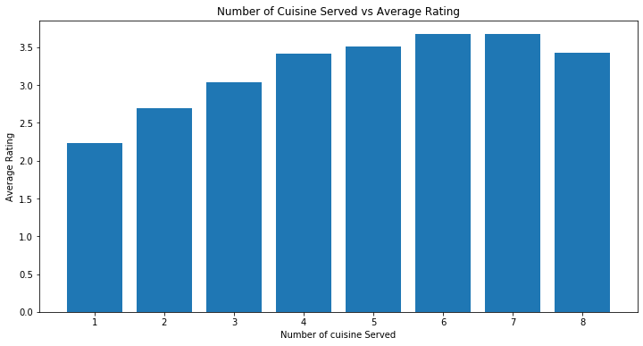

### Analysis:

Analysing this Graph, we can easily make out the trend.

1. As the number of cuisines increases , the Average User Rating increases.
2. If we look at the graph we see that serving 8 cuisines have less user-rating than serving 7. This could be because the restaurant fails to deliver every cuisine upto to the mark.

Therefore a Restaurant should not serve more than 6 or 7 cuisines or even less to avoid low Rating.

## 2.3 Average Cost of Restaurant VS USer Rating

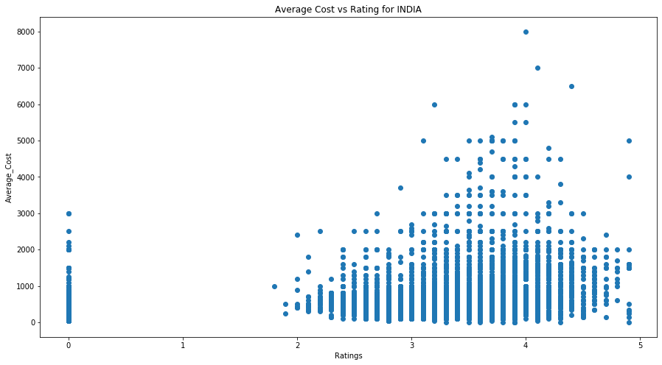

### Analysis

As we look into this graph, we can observe the following points:

1. There are very less or not at all restaurant with Rating less than **2,** and those who those who exists , have low Average Cost.
2. In Rating **2** to **3** we can see that the average cost is not more than 3000
3. In Rating **3** to **4** we see maximum number of Restaurants, and cost going up to 6000.
4. In Rating **4** to **5**  we can see that maximum number of restaurants having rating high, don’t have average cost high too.

Therefore We can see that Having less Average Cost i.e. having better value for money is important for a customer and the best range is having Average Cost less than 2000.

## Restaurant serving some specific cuisines Vs USer Rating

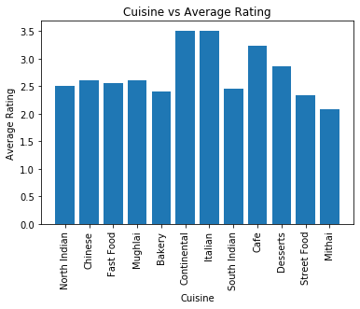\

### Analysis:

Analysing this Graph, we can easily make out the trend:

1. Restaurant Selling Continental and Italian , results in better User-Rating.
2. Restaurant selling Café and Desserts have better than average rating.
3. Restaurant selling just Mithai gets the lowest rating out of every cuisine.

## 2.2.1 Find the weighted restaurant rating of each locality and find out the top 10 localities with more weighted restaurant rating?

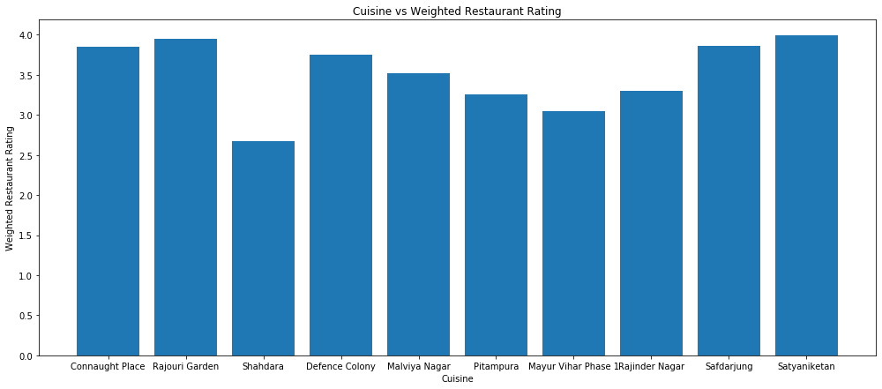

##### tOP 10 LOCALITIES WITH WEIGHTED RESTAURANT RATING

**Connaught Place | 3.85058739**

**Rajouri Garden | 3.95026857**

**Shahdara | 2.67698057**

**Defence Colony | 3.75101936**

**Malviya Nagar | 3.51786435**

**Pitampura | 3.25551988**

**Mayur Vihar Phase | 3.05184989**

**Rajinder Nagar | 3.30493135**

**Safdarjung | 3.86026932**

**Satyaniketan | 3.98874711**

Visualization

## Plot the bar graph top 15 restaurants have a maximum number of outlets.

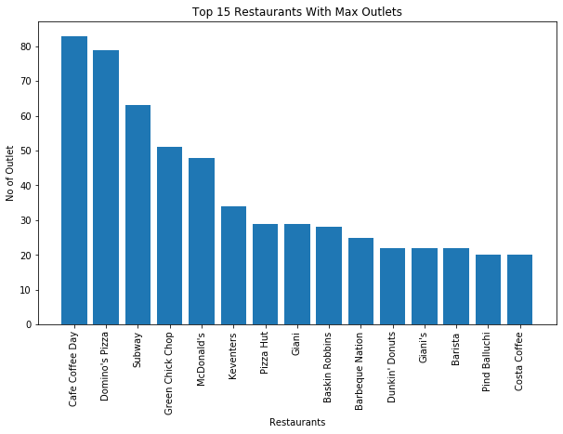

## Plot the histogram of aggregate rating of restaurant

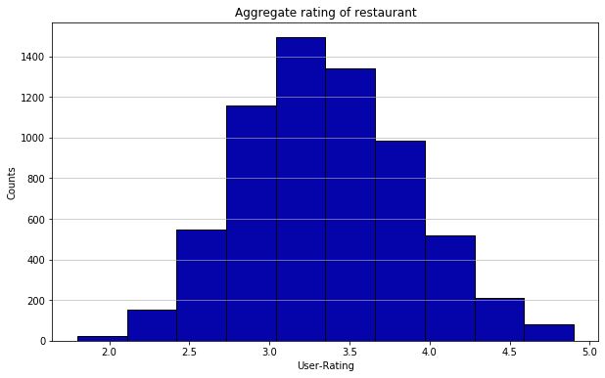

## Plot the bar graph top 10 restaurants in the data with the highest number of votes.

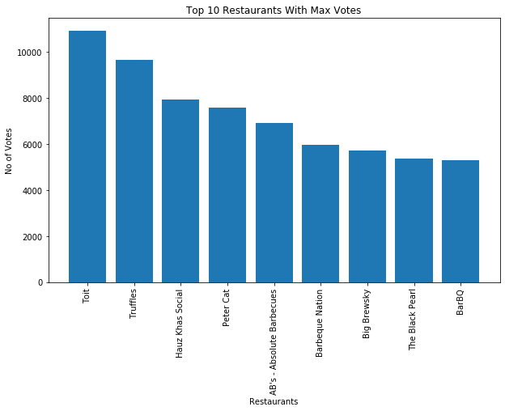

## Plot the pie graph of top 10 cuisines present in restaurants in the USA

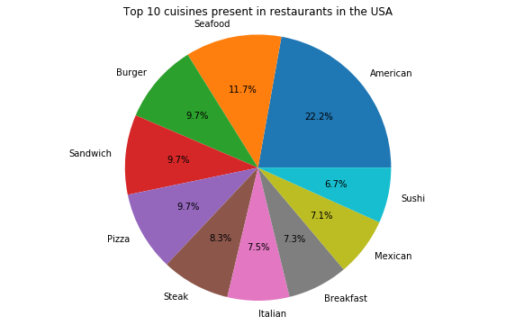

## Plot the bubble graph of a number of Restaurants present in the city of India and keeping the weighted restaurant rating of the city in a bubble.

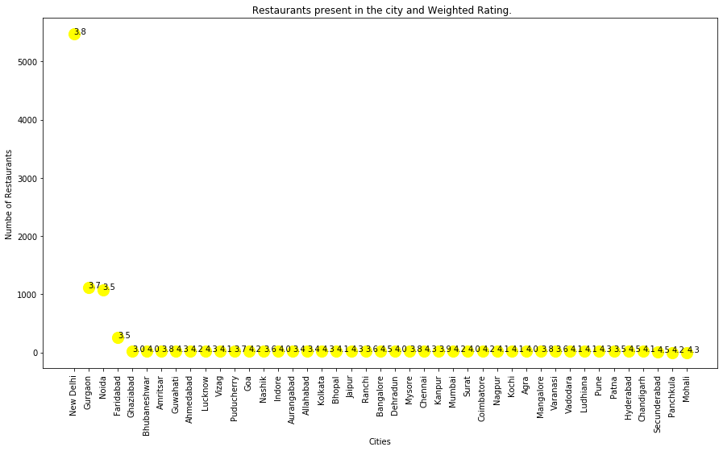

###### Formula Used to calculate Weighted Rating:

**Weighted Restaurant Rating=Σ (number of votes * rating) / Σ (number of votes) .**